FOOD TRENDS: UNDERSTANDING CUSTOMER PREFERENCES IN THE FOOD BUSINESS
A Data Analytics & Business Intelligence Project Using Power BI
Submitted by:
Deekshitha K
B.Tech – ECE

ACKNOWLEDGEMENT
I would like to express my sincere gratitude to my project guide for their continuous support, valuable guidance, and encouragement throughout the completion of this project. Their insights and suggestions have greatly contributed to the successful execution of this work.
I am also thankful to the faculty members of the Department of Electronics and Communication Engineering for providing the necessary knowledge and support during the course of this project. I extend my heartfelt thanks to my institution for offering the resources and environment required to carry out this work effectively.
I would like to acknowledge my friends and peers for their constant motivation, cooperation, and support during the development of this project.
Finally, I would like to thank various online platforms, tutorials, and resources that helped me gain a better understanding of Power BI, data analytics, and business intelligence concepts.

ABSTRACT
This project, titled “Food Trends: Understanding Customer Preferences in the Food Business,” aims to analyse customer behaviour and preferences in the food delivery industry using data analytics and business intelligence techniques. The study is based on the Swiggy All Menus India dataset, which contains over 197,000 records of food items, including details such as price, category, ratings, and customer review counts.
The project begins with data cleaning and preprocessing to ensure accuracy and consistency by handling missing values, removing duplicates, and correcting data types. Further, feature engineering techniques are applied to derive meaningful attributes such as Price Range, Engagement Level, Popularity Score, and Sentiment Classification. A rating-based sentiment analysis approach is used to categorize customer feedback into Positive, Neutral, and Negative sentiments, and a Sentiment Index is calculated to evaluate overall customer satisfaction.
Using Power BI, multiple interactive dashboards are developed to visualize insights. The Data Visualization Dashboard provides an overview of key metrics and category performance. The Sentiment Analysis Module analyses emotional trends across products and pricing tiers. The Product Insights Dashboard evaluates dish performance and engagement patterns. The Customer Segmentation Dashboard identifies different behavioural segments based on engagement and sentiment. Finally, the Strategy and Innovation Dashboard highlights business opportunities and provides actionable recommendations.
The analysis reveals that the majority of products receive positive sentiment, with budget and mid-range pricing tiers showing higher customer satisfaction and engagement. It also highlights that a small number of products contribute significantly to overall engagement, indicating the importance of targeted strategies.
Overall, this project demonstrates how data-driven insights can help improve product offerings, optimize pricing strategies, enhance customer satisfaction, and support effective decision-making in the food business.

TABLE OF CONTENTS
- Title Page
- Acknowledgement
- Abstract
- Introduction
- Problem Statement
- Objectives of the Project
- Dataset Description
- Methodology
  - Data Collection
  - Data Cleaning
  - Data Transformation
  - Data Modeling (DAX)
  - Visualization Approach
- Data Preprocessing
- Feature Engineering
- Data Visualization Dashboard
- Sentiment Analysis Module
- Product Insights Dashboard
- Customer Segmentation Dashboard
- Strategy & Innovation Dashboard
- Key Insights
- Conclusion
- Future Scope
- References

- INTRODUCTION
The food-tech industry has grown rapidly with the rise of online food delivery platforms like Swiggy, which generate large amounts of data related to customer preferences, pricing, and engagement. Analysing this data is important to understand customer behaviour and improve business performance. This project, titled “Food Trends: Understanding Customer Preferences in the Food Business,” focuses on analysing food menu data to identify patterns in customer ratings, pricing, and engagement. Using Power BI and data analytics techniques, the project transforms raw data into meaningful insights. Key techniques such as data cleaning, feature engineering, and sentiment analysis are applied to evaluate product performance and customer satisfaction. Multiple interactive dashboards are developed to visualize insights related to sentiment, product performance, customer segmentation, and business strategy. Overall, this project demonstrates how data-driven analysis can help improve decision-making, optimize pricing strategies, and enhance customer experience in the food industry.
- PROBLEM STATEMENT
The food delivery industry generates large amounts of data related to customer ratings, pricing, and engagement, but this data is often not effectively utilized for decision-making. It is challenging to identify customer preferences, evaluate product performance, and understand how pricing impacts satisfaction. This project aims to analyze food menu data to extract meaningful insights, perform sentiment analysis, and support data-driven decisions for improving product strategy and customer experience.
- OBJECTIVES OF THE PROJECT
The main objectives of this project are:
- To analyze customer preferences using ratings, reviews, and product categories.
- To clean and preprocess the dataset for accurate analysis.
- To create new features such as Price Range, Engagement Level, and Popularity Score.
- To perform sentiment analysis by classifying feedback into Positive, Neutral, and Negative.
- To evaluate product performance and identify top-performing and underperforming dishes.
- To study the impact of pricing on customer satisfaction and engagement.
- To build interactive dashboards using Power BI for data visualization.
- To provide data-driven insights and business recommendations.

- METHODOLOGY
The methodology of this project describes the systematic process followed to analyze the dataset and extract meaningful insights. It involves multiple stages, including data collection, data cleaning, transformation, modeling, and visualization. Each step plays a crucial role in ensuring the accuracy and effectiveness of the analysis.
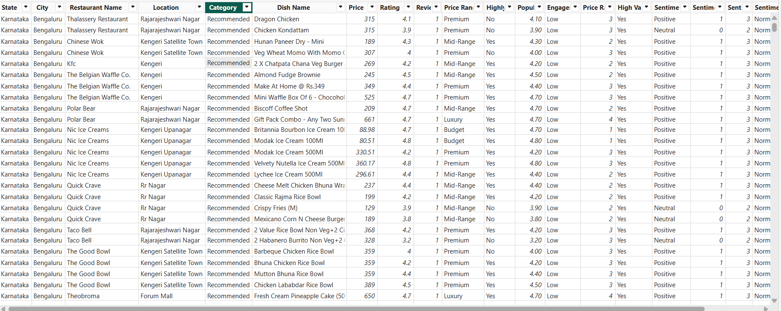
Data Collection
The dataset used for this project is the Swiggy All Menus – India dataset, which contains detailed information about food items offered by restaurants. The dataset was obtained in CSV format and includes over 197,000 records. Each record represents a unique dish and contains attributes such as state, city, restaurant name, category, dish name, price, rating, and review count. The dataset provides both categorical and numerical data, making it suitable for analyzing customer preferences, pricing strategies, and engagement patterns.
Data Cleaning
Data cleaning is a critical step to ensure data quality and reliability. The following operations were performed:
- Missing or null values were identified and removed or handled appropriately.
- Duplicate records were removed to avoid redundancy.
- Unrated dishes (rating = 0) were filtered out, as they do not contribute to customer preference analysis.
- Text fields were cleaned using trimming and formatting techniques to remove extra spaces and inconsistencies.
- Column names were standardized for better readability and usability.
These steps ensured that the dataset was clean, consistent, and ready for further analysis.
Data Transformation
Data transformation involves converting the raw dataset into a structured format suitable for analysis.
- Data types were corrected (e.g., price as numeric, rating as decimal).
- Columns were renamed for clarity and consistency.
- Data was organized into meaningful formats for easy visualization.
- Sorting and grouping were applied where necessary to improve data interpretation.
This step ensured that the data was properly structured and ready for modelling and visualization.
Data Modeling (DAX)
Data modelling was performed using DAX (Data Analysis Expressions) in Power BI to create calculated columns and measures for advanced analysis.
The following key features were developed:
- Price Range: Categorized dishes into Budget, Mid-range, Premium, and Luxury segments based on price.
- Engagement Level: Classified dishes into Low, Medium, High, and Very High based on review count.
- Popularity Score: Calculated as Rating × Review Count to measure product performance.
- Highly Rated Flag: Identified dishes with ratings above a defined threshold.
- Sentiment Classification: Converted ratings into Positive, Neutral, and Negative categories.
- Sentiment Index: A weighted measure used to evaluate overall customer satisfaction.
These calculations enhanced the analytical depth and enabled better insights.
Visualization Approach
The final step involved designing interactive dashboards using Power BI to present insights in a clear and intuitive manner.
Multiple dashboards were created:
- Data Visualization Dashboard: Provides an overview of key metrics and trends.
- Sentiment Analysis Dashboard: Analyses customer sentiment across categories and price ranges.
- Product Insights Dashboard: Evaluates dish performance and engagement.
- Customer Segmentation Dashboard: Identifies different customer behavior segments.
- Strategy & Innovation Dashboard: Highlights business opportunities and recommendations.
Charts such as bar charts, pie charts, scatter plots, funnel charts, and matrices were used to effectively communicate insights.
The dashboards include interactive filters(slicers), dynamic visuals, and conditional formatting to enhance user experience and decision-making.
- DATA PREPROCESSING
Data preprocessing is an important step to prepare the dataset for accurate analysis. In this project, several preprocessing techniques were applied to improve data quality and consistency. Missing values were identified and handled appropriately to avoid errors in analysis. Duplicate records were removed to ensure that each entry represents a unique dish. Data types were corrected, such as converting price to numerical format and rating to decimal values. Additionally, dishes with no ratings (rating = 0) were filtered out, as they do not provide useful information about customer preferences. Text fields were also cleaned by removing extra spaces and standardizing formats.
These preprocessing steps ensured that the dataset was clean, reliable, and ready for further analysis and visualization.
Feature Engineering
Feature engineering was performed to create new meaningful attributes from the existing data, enabling deeper analysis and better insights. In this project, several new features were developed. The Price Range column categorizes dishes into Budget, Mid-range, Premium, and Luxury based on their price. The Engagement Level classifies dishes into Low, Medium, High, and Very High based on the number of reviews. A Popularity Score was calculated using the formula Rating × Review Count to measure overall product performance. A Highly Rated flag was also created to identify dishes with high customer ratings. For sentiment analysis, ratings were converted into Positive, Neutral, and Negative categories. Additionally, a Sentiment Index was calculated as a weighted measure to represent overall customer satisfaction.
These engineered features helped in enhancing the analysis and enabled more effective visualization and business insights.
- DATA VISUALIZATION DASHBOARD
The Data Visualization Dashboard provides an overall view of the dataset and presents key insights related to customer preferences, pricing, and product performance. This dashboard serves as the foundation of the analysis by summarizing important metrics and trends in an easy-to-understand visual format.
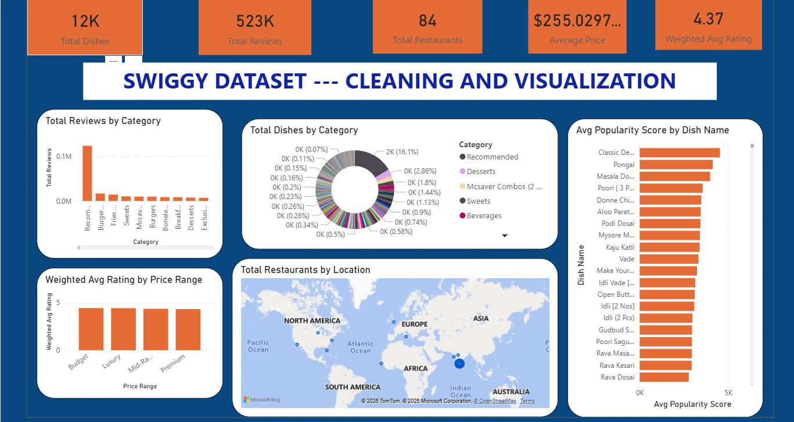
The dashboard includes several key performance indicators (KPIs) such as Total Dishes, Total Reviews, Average Rating, and Average Price. These KPIs provide a quick overview of the overall performance of the food items available on the platform. Various visualizations are used to analyze different aspects of the data. Category-wise analysis is performed to understand which types of food are most popular and receive higher ratings. Price-based analysis helps in identifying how pricing affects customer satisfaction and engagement. Charts such as bar graphs and column charts are used to compare ratings and review counts across different categories and price ranges. The dashboard also includes location-based insights, which help in identifying how customer preferences vary across different areas. This enables a better understanding of regional trends and restaurant performance.
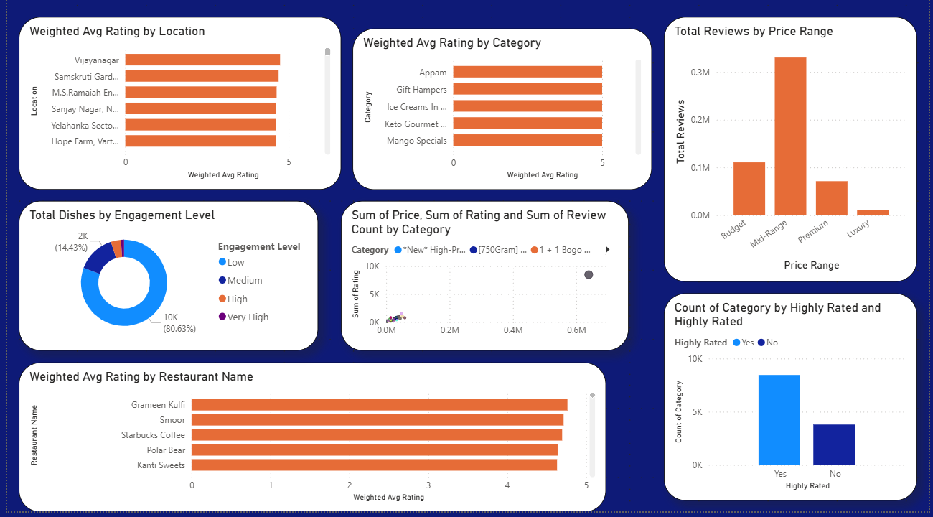
Overall, the Data Visualization Dashboard transforms raw data into meaningful insights by highlighting patterns and trends. It provides a clear understanding of customer behavior and acts as a base for further analysis in other modules such as sentiment analysis and product insights.
- SENTIMENT ANALYSIS MODULE
The Sentiment Analysis Module is designed to evaluate customer satisfaction by converting ratings into sentiment categories. Since the dataset does not include textual reviews, a rating-based approach is used to classify feedback into Positive, Neutral, and Negative sentiments. Ratings greater than or equal to 4 are considered Positive, ratings between 3 and 3.9 are Neutral, and ratings below 3 are Negative. Additionally, a Sentiment Index is calculated as a weighted measure using review counts to represent overall customer satisfaction more accurately. The dashboard includes visualizations such as donut charts for sentiment distribution, stacked bar charts for category-wise sentiment analysis, and column charts for sentiment comparison across price ranges. The analysis shows that most products receive positive sentiment, with budget and mid-range items performing better in terms of customer satisfaction.
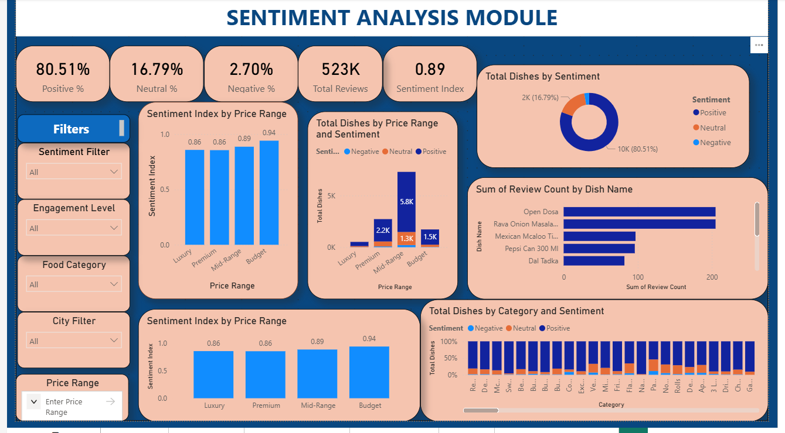
This module helps in understanding customer emotions and identifying areas that require improvement.
- PRODUCT INSIGHTS DASHBOARD
The Product Insights Dashboard focuses on evaluating the performance of individual dishes and restaurants. It helps identify top-performing and underperforming products based on metrics such as rating, review count, and popularity score. The dashboard includes key performance indicators such as total dishes, average rating, total reviews, and average popularity score. Visualizations such as bar charts are used to display the top 10 dishes and top-performing restaurants. A funnel chart is used to represent the product performance pipeline, showing how many dishes progress from total items to highly rated and high-engagement products. Additionally, engagement distribution charts highlight how customer interaction varies across different products.
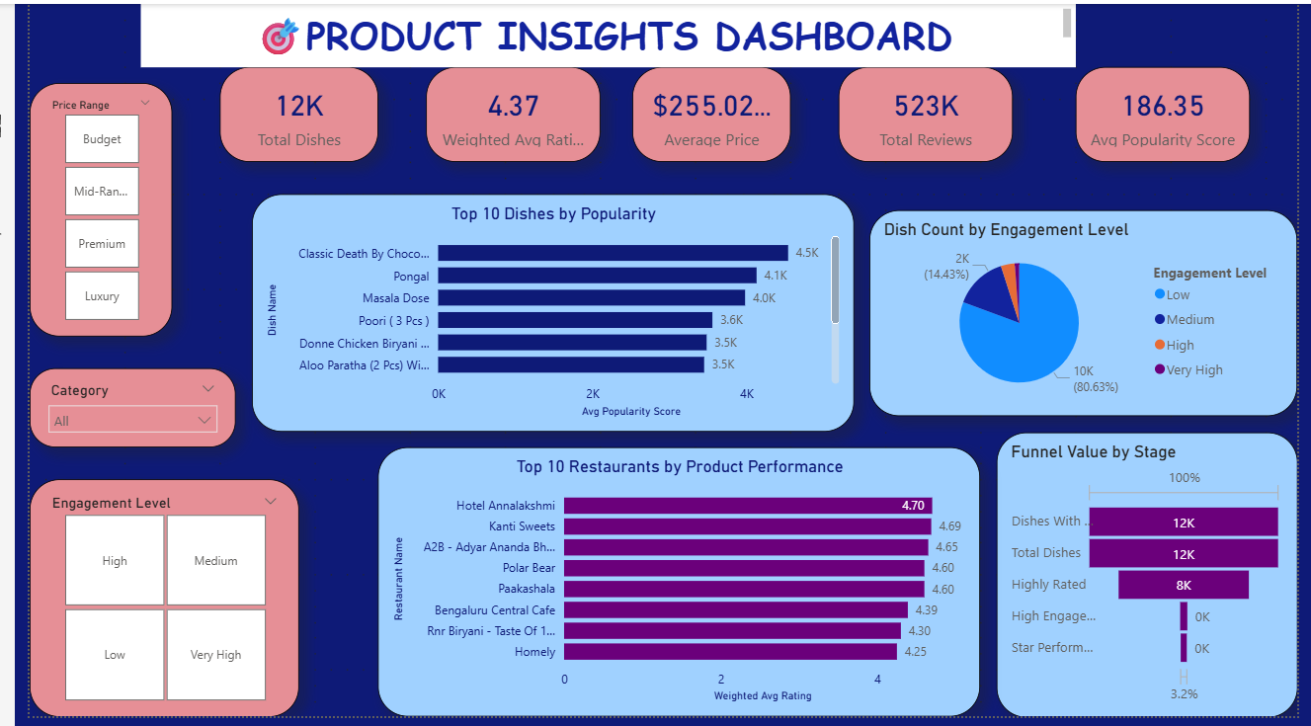
The analysis reveals that only a small number of dishes contribute significantly to overall engagement, indicating the importance of focusing on high-performing items.
- CUSTOMER SEGMENTATION DASHBOARD
The Customer Segmentation Dashboard aims to analyse customer behaviour by grouping products based on engagement levels, sentiment, and preferences. Since the dataset does not contain individual customer data, behavioural segmentation is used. Dishes are categorized into different segments such as Low, Medium, High, and Very High engagement based on review counts. Sentiment segmentation is also applied to understand how different customer groups perceive products. The dashboard includes visualizations such as donut charts for engagement distribution, scatter plots for analysing the relationship between ratings and review counts, and stacked charts for sentiment distribution across categories. The analysis shows that most products fall under low engagement, while only a few achieve high engagement. It also highlights that some highly rated products have low visibility, indicating potential opportunities for improvement.
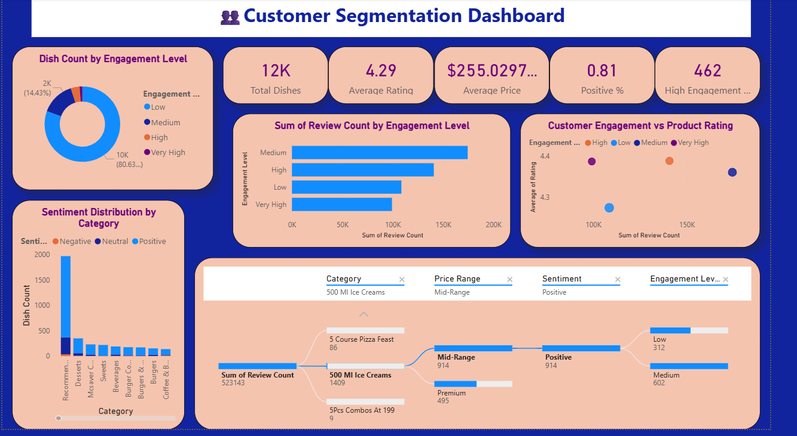
This dashboard helps in understanding customer behaviour and identifying different segments for targeted strategies.
- STRATEGY & INNOVATION DASHBOARD
The Strategy & Innovation Dashboard focuses on transforming analytical insights into actionable business strategies. It combines findings from all previous dashboards to support decision-making. This dashboard includes strategic KPIs such as total reviews, sentiment index, average price, and number of star-performing products. It also highlights top-performing categories, pricing trends, and customer engagement patterns. Visualizations such as bar charts, scatter plots, and donut charts are used to identify innovation opportunities and risk areas. For example, high-rated but low-engagement products are identified as potential growth opportunities, while high-priced low-rated items are flagged as risk areas. The analysis indicates that budget-friendly products generate higher customer satisfaction, and a small group of products drives most engagement. Based on these insights, recommendations are provided for improving product visibility, optimizing pricing strategies, and enhancing customer engagement.
Overall, this dashboard acts as a decision-support system by converting data insights into strategic actions.
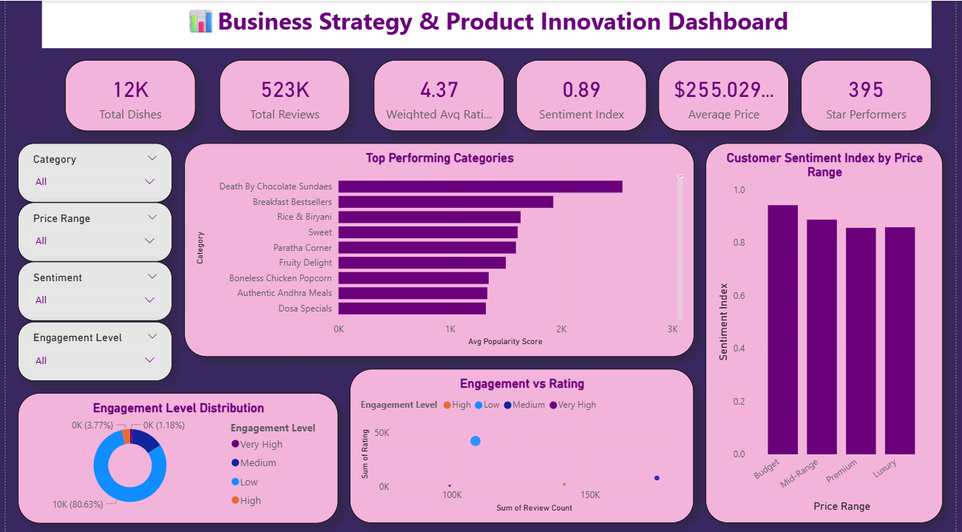

FINAL ANALYSIS
- KEY INSIGHTS
The analysis of the Swiggy dataset provides several important insights into customer behaviour and product performance in the food business.
Firstly, it is observed that a large majority of dishes receive positive sentiment, indicating overall customer satisfaction with food offerings. Negative sentiment is minimal, which suggests that most products meet customer expectations.
Secondly, pricing plays a significant role in customer satisfaction. Budget and mid-range food items tend to receive higher ratings and better sentiment compared to premium and luxury items. This indicates that customers prefer value-for-money options.
Another key observation is that only a small number of dishes contribute to the majority of customer engagement. These high-performing dishes attract a large number of reviews and maintain high ratings, making them critical for business success.
Additionally, customer engagement is unevenly distributed, with most products falling into low engagement categories. This highlights the need for better promotion and visibility of underperforming items.
Category-level analysis shows that certain food categories consistently perform better in terms of ratings and popularity, indicating strong customer demand in those segments.
- CONCLUSION
This project successfully demonstrates the use of data analytics and business intelligence techniques to understand customer preferences in the food business. By analyzing the Swiggy All Menus dataset, meaningful insights were extracted regarding customer behavior, product performance, pricing strategies, and sentiment patterns. Through data cleaning, preprocessing, and feature engineering, the dataset was transformed into a structured format suitable for analysis. The use of Power BI enabled the creation of interactive dashboards that effectively visualize key insights. The project highlights that data-driven decision-making can significantly improve business strategies, including menu optimization, pricing decisions, and customer engagement. It also emphasizes the importance of focusing on high-performing products and identifying areas for improvement. Overall, this project provides a comprehensive understanding of how analytics can be applied in the food industry to enhance customer satisfaction and drive business growth.

- FUTURE SCOPE
Although the project provides valuable insights, there are several areas for future improvement and expansion.
One major enhancement would be the inclusion of text-based customer reviews, which would allow the use of Natural Language Processing (NLP) techniques for more accurate sentiment analysis. This would provide deeper insights into customer opinions.
Another improvement could be the use of real-time data integration, enabling businesses to monitor trends dynamically and make quicker decisions.
The project can also be extended by implementing machine learning models to predict customer preferences, demand trends, and product success.
Additionally, an AI-based recommendation system can be developed to suggest food items to customers based on their preferences and behavior.
These enhancements would make the system more advanced and suitable for real-world applications.

- REFERENCES
- Swiggy All Menus India Dataset (Kaggle / Online Source)
- Microsoft Power BI Official Documentation
- DAX (Data Analysis Expressions) Documentation
- Online tutorials and learning platforms (YouTube, Coursera, etc.)
- Research articles on data analytics and food industry trends

